Sponsorship & Exhibition Prospectus

2023 Users' Meeting & Workshops
National Synchrotron Radiation Research Center (NSRRC)
October 24-26, 2023

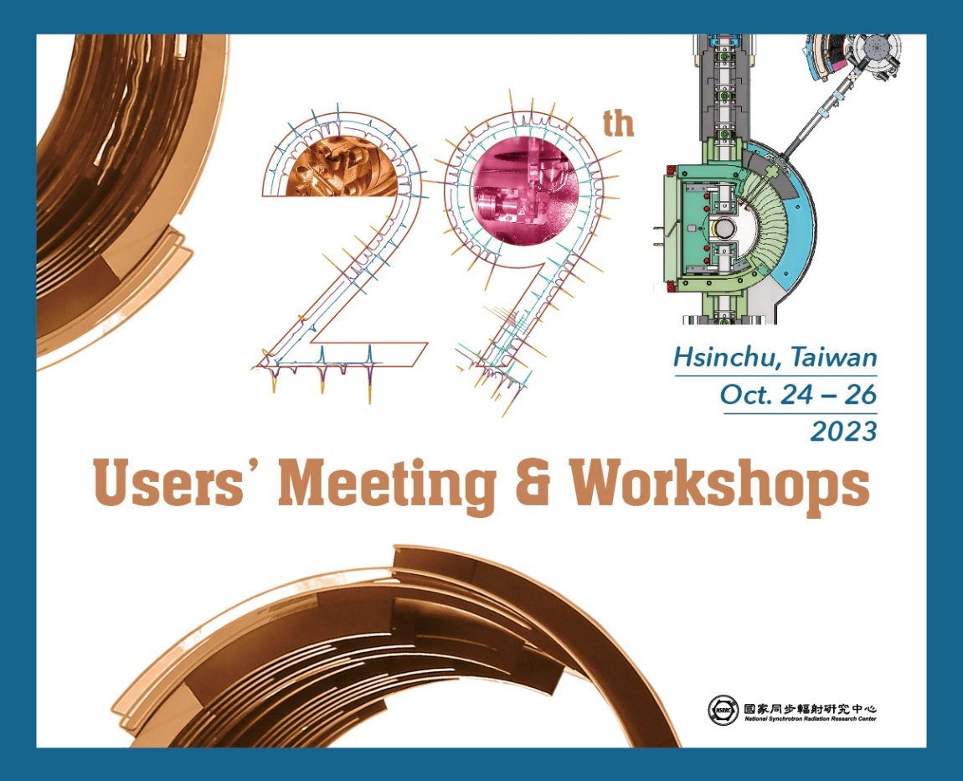

Welcome

Thank you for your support as always. The National Synchrotron Radiation Research Center (NSRRC) is pleased to invite you to sign up for the sponsorship and exhibition opportunities at the 29th Users' Meeting & Workshops, taking place in Hsinchu, Taiwan from October 24 to 26, 2023. The program will include a series of talks, poster and exhibition session, user town meeting and workshops, but also the 30-year celebration of Taiwan Light Source, the NSRRC Outstanding Paper Award ceremony, and some fun social events. .

We are expecting our three-day program to be even more successful, with around 400-450 attendees this year. Many of them are interested in knowing more about our current phase-II and phase-III projects of the Taiwan Photon Source. While we show them how phase-II and phase-III beamlines and their techniques can facilitate their research, this will also be an excellent opportunity for you to demonstrate your products and the services, reconnect with old customers and make business connections with potential clients.

Please take a look at the prospectus we have put together for you. Make your selection, fill in the booking form and send it to us at lin.yk@nsrrc.org.tw. We will follow up with you shortly after that. The opportunities are available on a first come first serve basis; therefore, we encourage you to book your space as soon as possible. Please feel free to contact us if you need additional information on this event. We look forward to hearing from you!

Sincerely,
User Executive Committee
National Synchrotron Radiation Research Center

Sponsorship & Exhibition Opportunities
*All prices are inclusive of VAT if applicable.
*All sponsors and exhibitors will receive 2 complimentary registrations.
*All sponsors and exhibitors will receive acknowledgement including hyperlinked organization logo on the event website.
Advertisement | Price (USD) | Opportunities
Brochure Display & Distribution  @ the registration counter  @ main conference room | $600 | 4
Interactive kiosk Advertising - one page | $600 | 4
Interactive kiosk Advertising - Promotional Video (up to 1 min.) | $1,000 | 4
Sponsor Presentation on 10/25 (15 min.) | $2,300 | exclusive
Food Sponsorship  *Acknowledgement poster(s) will be displayed in the area where the food is served. | Price (USD) | Opportunities
Coffee Break | $600 | 4
Lunch | $1,000 | 2
Welcome Reception on 10/24 | $2,000 | exclusive
Breakfast on 10/25 | $600 | exclusive
Banquet on 10/25 | $3,000 | 4
Exhibition | Price (USD) | Opportunities
Booth (3m x 2m)  - The dimension of each booth: 3m x 2m (W x D)  - Each booth will be provided with lighting, power outlet (5A/110V), 1‐line signage, 1 table and 2 chairs.  - Other requests are possible at exhibitor’s additional cost. | $3,300 | 8
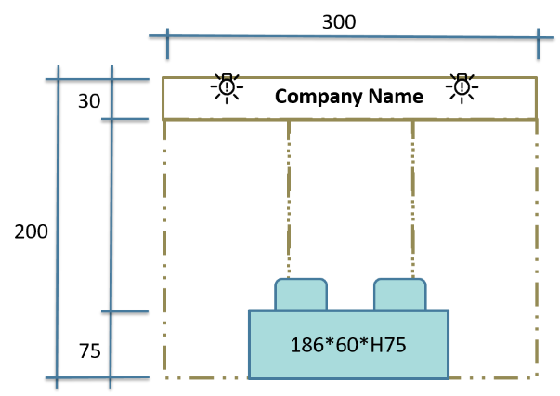
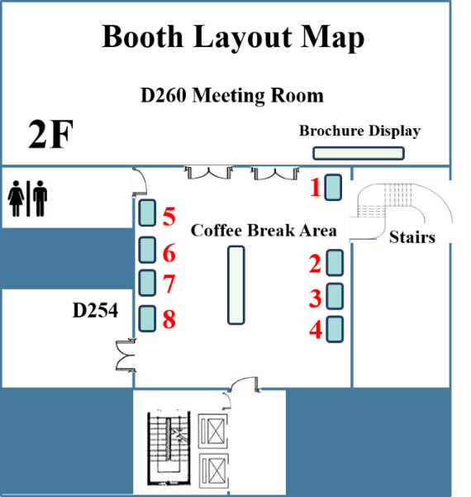

Booth dimension
Important Dates & Schedules
Application Deadline | Please email us your “Order Form” by August 25.
Payment | Payment should be made in full by September 1.
Company Logo | Please provide us with your company logo (300 dpi) by September 1.
Brochure Display & Distribution | All brochures must arrive by September 1.
Booth | Exhibition Dates: October 24 − 26, 2023  Exhibitor Setup: October 24, 2023  Booth Dismantling: October 26, 2023
Sponsor Presentation | Please test the presentation equipment at least 15 minutes before the presentation.

Terms & Conditions
- Bookings are subject to limited availability. Exhibitors are given priority to select their booth locations when full payment is made and confirmed – first come, first served.
- Exhibitors with demonstrating instruments must carry their own insurance. Neither organizers, contractors nor staff of NSRRC have responsibility for any merchandise or displayed materials, which may become lost, stolen or damaged, under any circumstances. Exhibitors must contact the shipping company and handle the shipment by themselves.
- All demonstrating instruments are strongly suggested sent to the NSRRC through FedEx to pass the customs formalities.
- NSRRC reserves the right to change the exhibition floor layout or booth locations if necessary.

Payment & Confirmation
Please be aware that all local and oversea charges should be borne by the payer and the payment should arrive in full. A confirmation email will be sent after the payment is received.
Wire Transfer Instruction:
Account Name: National Synchrotron Radiation Research Center
Account Number: 073001106939
Name of Bank: BANK OF TAIWAN (Science‐Based Industrial Park Branch)
SWIFT Code: BKTWTWTP073

Cancellation Policy
Cancellation must be requested through emailing lin.yk@nsrrc.org.tw. A fee of 15% of total fees applies for cancellations prior to 2023/09/15. No refund will be made for cancellation after this date.

Contact
For any enquiries regarding sponsorship and exhibition, please contact:
Ms. Yin-Ku Lin
TEL: +886‐3‐5780281 #8225
Email: lin.yk@nsrrc.org.tw
Order Form

Please complete and submit this form to the NSRRC by emailing lin.yk@nsrrc.org.tw before August 25. We should contact you shortly; if not, please call +886-3-5780281#8225 for confirmation. Bookings are valid only when full payment is made and received by September 1.
Date： (yyyy) (mm) (dd)
COMPANY INFO
Name (in English)
Name (in Chinese if any)
Title of Invoice/Receipt |  | - the same as company name  or __________________________________________ |  |  | VAT #
Address
Website
CONTACT PERSON
Name |  |  | Title | □ Ms. □ Mr. □ Dr. □ Prof.
Dept. |  |  | Position
Telephone |  |  | E-mail
ORDER ITEMS
Unit | Advertising |  |  |  | Unit Price (USD)
 | Brochure Display & Distribution |  |  |  | $600
 | Interactive kiosk Advertising - one page |  |  |  | $600
 | Interactive kiosk Advertising - Promotional Video (up to 1 min.) |  |  |  | $1,000
 | Sponsor Presentation on 10/25 (15 min.) |  |  |  | $2,300
Unit | Food Sponsorship |  |  |  | Unit Price (USD)
 | Coffee Break |  |  |  | $600
 | Lunch |  |  |  | $1,000
 | Welcome Reception on 10/24 |  |  |  | $2,000
 | Breakfast on 10/25 |  |  |  | $600
 | Banquet Sponsorship on 10/25 |  |  |  | $3,000
Unit | Exhibition |  |  |  | Unit Price (USD)
 | Booth (3m x 2m) |  |  |  | $3,300
TOTAL AMOUNT (USD)
Signature of Company Applicant _________________________
PLEASE EMAIL THIS FORM

